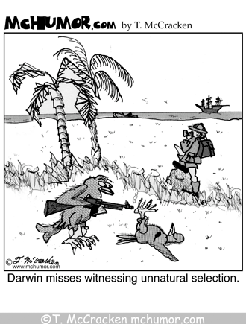
Biology / Evolution Unit
Biology -- Intro to Evolution Assignment

PART I: WEBQUEST VIDEO QUESTIONS

Directions: Follow the links below and answer all questions in your journal.

Video 1: Isn’t Evolution a Theory?
https://www.youtube.com/watch?v=XsZV90wOzOk&t=2s

1. How does the scientific community use the term “theory” and how is it different from the way people use it in everyday language?

2. What are some other theories in science? Name at least 3 more. Do these other theories seem controversial? Why or why not?

3. Explain as best you can at this point why you think evolution draws controversy and why other scientific theories do not.

Video 2: Who was Charles Darwin?
https://www.youtube.com/watch?v=6GNUlZhE_jE (there is only sound for this clip)

4. Describe the political and religious environment that surrounded Darwin.

5. Was Darwin himself a religious man?

6. Explain how he used the scientific process and data analysis to come up with the Theory of Natural Selection.

7. Explain why he eventually presented his ideas despite his reservations.

8. How has modern methods of experimentation and new scientific fields confirmed Darwin’s Theory?

PART II: History Behind Darwin’s Theory of Evolution

Directions: REDRAW this chart in your journal and use Chapter 15-2 in Dragonfly Bio text to answer and fill out the chart.

Scientist | Year(s)  of interest | Summary of their ideas or  findings (This column should be BIG!) | How did it influence/contribute  to Darwin’s ideas? (This column should be BIG, too!) | Were their ideas  eventually proven right/wrong?
James Hutton
Charles Lyell
Jean Baptiste
Lamark
Thomas
Malthus

Biology / Evolution Unit
Biology -- Intro to Evolution Assignment

PART I: WEBQUEST VIDEO QUESTIONS

Directions: Follow the links below and answer all questions in your journal.

Video 1: Isn’t Evolution a Theory?
https://www.youtube.com/watch?v=XsZV90wOzOk&t=2s

1. How does the scientific community use the term “theory” and how is it different from the way people use it in everyday language?

2. What are some other theories in science? Name at least 3 more. Do these other theories seem controversial? Why or why not?

3. Explain as best you can at this point why you think evolution draws controversy and why other scientific theories do not.

Video 2: Who was Charles Darwin?
https://www.youtube.com/watch?v=6GNUlZhE_jE (there is only sound for this clip)

4. Describe the political and religious environment that surrounded Darwin.

5. Was Darwin himself a religious man?

6. Explain how he used the scientific process and data analysis to come up with the Theory of Natural Selection.

7. Explain why he eventually presented his ideas despite his reservations.

8. How has modern methods of experimentation and new scientific fields confirmed Darwin’s Theory?

PART II: History Behind Darwin’s Theory of Evolution

Directions: REDRAW this chart in your journal and use Chapter 15-2 in Dragonfly Bio text to answer and fill out the chart.

Scientist | Year(s)  of interest | Summary of their ideas or  findings (This column should be BIG!) | How did it influence/contribute  to Darwin’s ideas? (This column should be BIG, too!) | Were their ideas  eventually proven right/wrong?
James Hutton
Charles Lyell
Jean Baptiste
Lamark
Thomas
Malthus

