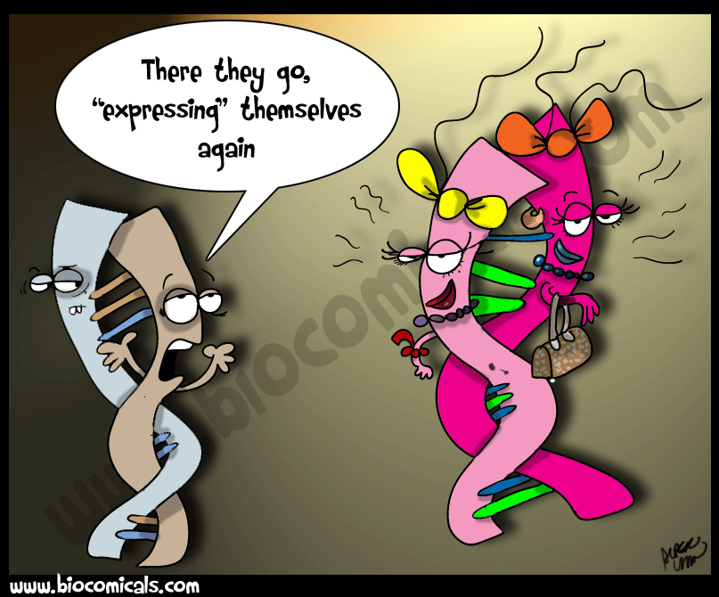
Learning to Express Yourself: Gene Expression Basics
(Adapted from H. Bankoff and S. Talle, Lakewood High School)

Purpose: To review the basic processes of transcription and translation and to review the overarching idea of how genes become traits.

Directions: Please answer all questions in your lab notebook!!
- In the beginning of the year, we talked about biomolecules. Proteins are a type of biomolecule. What are proteins made of?
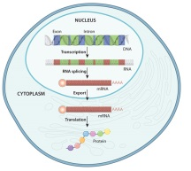
- How many different types of those things are there?
- What is the role or function of proteins in your body?
- What is one of the smallest proteins in your body?
- It’s made of how many amino acids?
- Describe the function of this protein.
- What is one of the largest protein in your body?
- It’s made of how many amino acids?
- Describe the function of this protein:

PhET Simulation Lab: Go to the website http://phet.colorado.edu/en/simulation/gene-expression-basics.
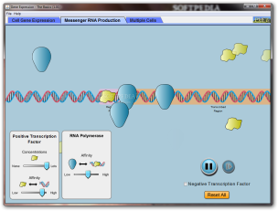
Click on the green “run now” box and open the simulation. You may have to click “keep” at the bottom of the web browser and click on the file after it downloads. Follow the steps below and answer the questions.
Gene #1:
- Examine the piece of DNA that runs across the screen. What are the 2 parts of Gene 1?

- Look in the biomolecule tool box on the left and grab a negative transcription factor, place it on the DNA. If you don’t put it in the right spot; it will float off the DNA and away. Where does the negative transcription factor stick to the DNA?

- Click on the negative transcription factor and drag it back to the tool box. Click on a positive transcription factor and put it on the DNA. Where does the positive transcription factor stick?

- Transcription factors are proteins that help regulate (control) the expression of a gene. When a gene is “expressed”, a messenger RNA is made and protein synthesis begins. Click on and drag the RNA polymerase from the biomolecule tool box and place it next to the positive transcription factor on the DNA. Describe what happens:

- You have just “transcribed” gene 1. What does the black squiggly line represent?

- Transcribe gene 1, three more times. What does the word part “trans” mean? What does the word part “script” mean? Explain how the term “transcription” fits with the process of making a mRNA.

- Where in your cells does transcription take place? In your cells, where do the mRNA’s go after they are made? Grab a ribosome from the tool box and get it close to one of the free floating mRNA’s. Describe what happens:

- What did the ribosome help make? Can you use the same mRNA more than once? Grab 2 more ribosomes and bring each one close to the other mRNAs that are free floating. Take each of the “proteins” and drag them into the “protein collection box”.

- The process of using a mRNA to make a protein is called: Where in your cells does this process take place? Grab some of the RNA destroyers, bring them near the mRNA’s and clean up your cytoplasm.

- Click over to the second gene. How is it different from gene #1? IN 2 WAYS?

- Transcribe gene #2 five times and put 5 proteins in your “protein collection box”.

- Click over to the 3rd gene. How is gene 3 different from the first two genes?

- Transcribe gene #3, seven times and put 7 proteins in your “protein collection box”.

- Trace the flow of information from DNA to a protein, write the names of the processes above each arrow.

DNA (gene) mRNA protein

- What you created above is known as “The Central Dogma of Biology”!! It is a BIG idea, remember it!! What is a “dogma”? Use an internet resource to find out if you’re not sure:

Video Analysis: Go to the website https://www.youtube.com/watch?v=5bLEDd-PSTQ As you watch the video, answer the following questions. You may have to watch the video a few times, pause it occasionally, or back it up to hear a phrase repeated.

- What are the three basic steps of Translation?

- As the video goes on, fill in details about what happens during each step.

- What base is the Poly-A Tail made of?

- What is in the middle of the strand of mRNA? How many bases compose each one of these?

- Where does the ribosome attach to the mRNA?

- What carries each amino acid to the ribosome and mRNA? Explain how this molecule matches the part of the mRNA to which it attaches.

- What happens to the amino acid that was attached to the first tRNA molecule when the second tRNA arrives at the next binding site? This process is known as:

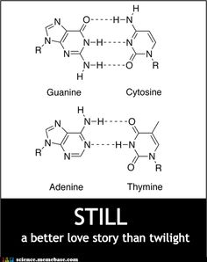
- When does elongation stop?

- What type of codon must be present on the mRNA to stop this process?

